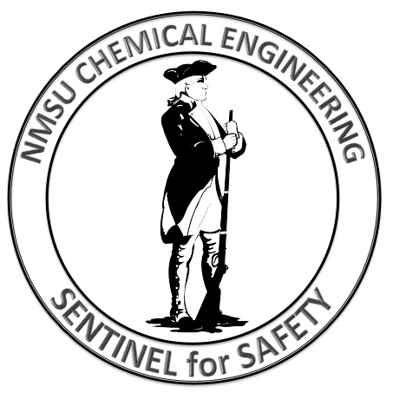
ALL ACCIDENTS CAN BE PREVENTED
NMSU CHEMICAL ENGINEERING
SAFETY SENTINAL REPORT FORM
All students and employees of New Mexico State University Chemical Engineering are Sentinels for Safety. It is our duty to maintain a vigilant watch and a critical eye on our procedures, processes, activities, and habits with the goal of improving these activities to assure that we all go home safely at the end of the work day.
Use this form to make the NMSU CH E Department Head aware of any potentially hazardous situation or procedure that you believe should be addressed or to suggest improvement to a process within the department that you believe may be carried out more safely.
Name: |  | Building:
Aggie ID: |  | Room No. or location:
Date:
Detailed description of your safety concern:

Proposed remedial actions to correct this situation:

